Lab 8: Managing Migrations and Schema Changes
Objective
To update the database schema by adding a new column (StockQuantity) to the Products table using Entity Framework Core Migrations.
Commands Used
dotnet ef migrations add AddStockQuantity
dotnet ef database update
Code
Program.cs
using RetailInventory.Data;
using var context = new AppDbContext();
Console.WriteLine("StockQuantity column added successfully.");
Category.cs
using System.Collections.Generic;
namespace RetailInventory.Models
{
public class Category
{
public int Id { get; set; }
public string Name { get; set; }
public List<Product> Products { get; set; } = new List<Product>();
}
}
Product.cs
namespace RetailInventory.Models
{
public class Product
{
public int Id { get; set; }
public string Name { get; set; }
public decimal Price { get; set; }
public int CategoryId { get; set; }
public Category Category { get; set; }
public int StockQuantity { get; set; }
}
}
AppDbContext.cs
using Microsoft.EntityFrameworkCore;
using RetailInventory.Models;
namespace RetailInventory.Data
{
public class AppDbContext : DbContext
{
public DbSet<Product> Products { get; set; }
public DbSet<Category> Categories { get; set; }
protected override void OnConfiguring(DbContextOptionsBuilder optionsBuilder)
{
optionsBuilder.UseSqlServer(
"Server=localhost\\SQLEXPRESS;Database=RetailDB;Trusted_Connection=True;TrustServerCertificate=True;");
}
protected override void OnModelCreating(ModelBuilder modelBuilder)
{
modelBuilder.Entity<Product>()
.Property(p => p.Price)
.HasPrecision(18, 2);
}
}
}
Output
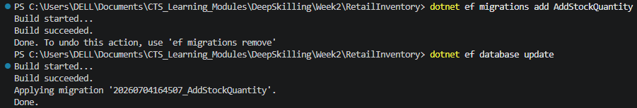
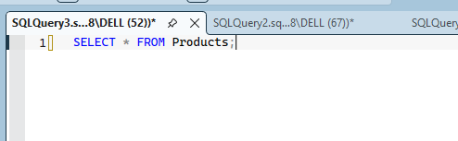
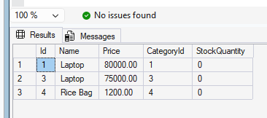
Result
The database schema was successfully updated by adding the StockQuantity column to the Products table using Entity Framework Core Migrations. The migration was applied successfully, and the new column was verified in SQL Server.

